Reading. Poland (3 Б.)
Прочитайте текст и дополните одним словом предложения.
People usually visit many countries. Read the text about Poland.
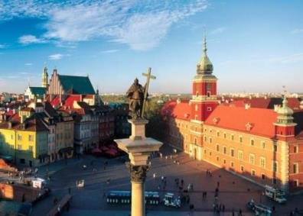

Whether you are interested in culture or countryside, Poland has something for you. With a long, fascinating history and rich traditions, it certainly won’t leave you bored.
Warsaw is the capital city and the cultural centre of Poland. Here you can visit the Royal Castle and Lazienki Park, as well as many museums and theatres. Don’t miss the Royal Route, a line of streets filled with grand palaces, ancient monuments, elegant shops, art galleries, and traditional restaurants and cafes. An evening of theatre, opera or ballet at the National Theatre or a performance of exquisite classical music from the Warsaw Philharmonic will be an unforgettable experience.
Those who want to relax and spend some time by the sea should visit one of Poland’s many health resorts in Pomerania. Nearby Warmia is the perfect place to relax by a beautiful lake or walk through a green forest. You can also go horse riding, whitewater rafting or take a trip up into the mountains.
With so much unspoiled countryside, and so many impressive sights, any visit to Poland is sure to be the experience of a lifetime!

Complete the sentences:
1. In Warsaw you can visit the Royal .
2. If you like spending time near water and in the forest, you should go to .
3. This text is about a beautiful country, called .

