Read the text "Abraham Lincoln".
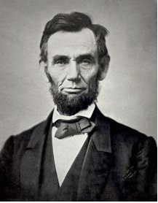

Lincoln was one of the most famous presidents of the USA. He was born in the family of a poor farmer in 1809 in Kentucky, but soon his family left for the wild forestland of Indiana. He was taught reading, writing and simple arithmetic, as his family could not afford better education. When he was 18, he went to New Orleans and there he saw a slave market. It made a deep impression on him and he began to hate slavery and he decided to fight against it.

In 1830 he went to Springfield and became a clerk in a store. He learned much and greatly improved his knowledge. He entered politics and in 1832 became a candidate for the Parliament of the State. Soon he became a force in political life and in 1860 was elected President of the USA. He was an enemy of slavery.

Some of the Southern States left the Union, and the war between the South and the North began. At first the war went badly for the North, but Lincoln never lost his courage and soon they won. When the war was over, Lincoln issued a proclamation to say that slavery was abolished.

Lincoln was well known all over America and everybody loved him. In 1864 he was elected President of the USA for the second time. But his enemies could not let him continue his work. He was shot in a theatre in Washington on April 14, 1865 and died the next day.

Write true, false, doesn’t say

1. It made a deep impression on him and he began to hate slavery and he decided to fight against it.
2. Lincoln entered science and in 1832 became a candidate for the Parliament of the State.
3. At first the war went badly for the South, but Lincoln never lost his courage and soon they won.

