Пройти по ссылке,прослушать диалог,заполнить пропуски в предложениях https://www.youtube.com/watch?time_continue=28&v=G9ZjekXyHGU&feature=emb_logo 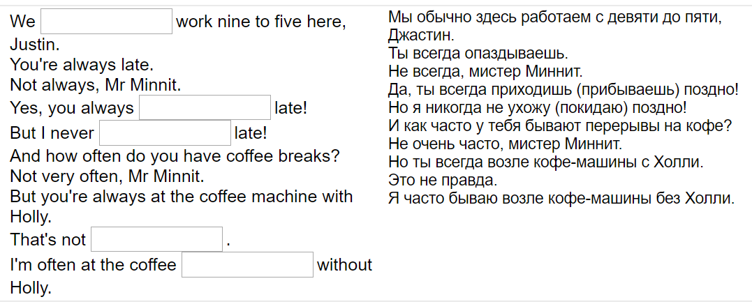
Прослушать следующий диалог,тоже заполнить пропуски в предложениях https://www.youtube.com/watch?v=XLhKTH-MP0s&feature=emb_logo
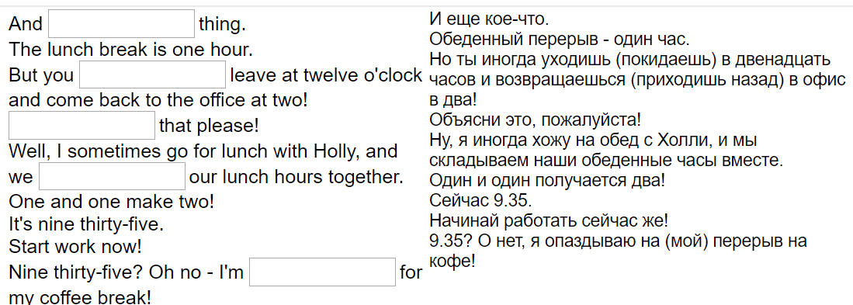

Из данных фраз составьте диалог

Диалог секретаря и посетителя в офисе (Dialogue between a secretary and an office guest)

- Good morning, sir. Do you have an appointment?
- I don’t think so. I need to see Mr. Watson personally.
- That’s right, Mr. Johnson. May I take your coat, please?
- Would you like to take a seat? I’ll see if he is available.
- Thank you very much.
- Sure.
- Yes, I have an appointment at 10 o’clock. My name is Sam Johnson.

- Well. Would you mind waiting a little, please? Mr. Watson is having an important international phone call at the moment. He won’t be long. But I can offer you to see his assistant if you’re in a hurry.
- Good morning! Can I see Mr. Watson, please?
- Can I offer you a cup of tea or coffee while you are waiting?
- Tea would be nice, thank you. I’m sorry but is there a smoking-room here on the floor?
- Thank you. Here you are. Is Mr. Watson in his office?
- No, smoking is not allowed in the building. I’m afraid you can do that outside only.
- OK. No problem.
- Well. Please, call me if you need anything. And I’ll let you know when Mr. Watson is free.
- Here is your tea. Please, help yourself to the cookies.

