1. Соотнесите рисунки с текстами, данными ниже
А | В | С | 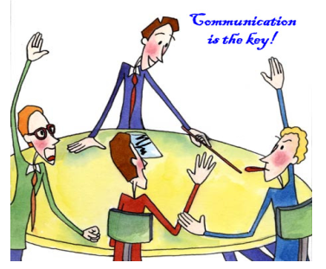  D

1.
A: Hello. I'm Mia Conners.
B: Hi, Mia. I'm David Sinclair, and this is my partner Gina Evans. (Hold out a hand to shake)
A: Nice to meet you Mr. Sinclair and Ms. Evans. Thank you for taking the time to meet with me today.
B: It's our pleasure. And please, call us David and Gina. Can I take your coat?
A: Thank you.
B: No problem. Please take a seat and we'll be right with you. I just have to make a quick phone all.
2.
Leslie: Hello.
Cameron: Hi, is this Leslie?
Leslie: Yes. Who’s this?
Cameron: It's Cameron here. Is Maria in?
Leslie: No, she just stepped out for a moment. Can I take a message?
Cameron: Yes, thanks. Please ask her to meet me at the Capitol 4 movie theatre at 7 pm tonight.
Leslie: Sure. Just let me write that down. Oh, Cameron, could you hold for a second? I have to take another call.
Cameron: No problem.
3.
Dear Andy:
How have you been? Your mother and I are fine. We miss you. Please sign off your computer and come downstairs for something to eat.
Love,
Dad
2. Распределите данные ниже слова, описывающие процессы, изображенных на них видов коммуникации, в две колонки.
Speaking, writing, listening, reading, a formal vocabulary, a slang, an ear, full sentences, a hand,
punctuation marks, a mouth, facial expression, a tone of voice, correct grammar, sentences, sentences and paragraphs, oral communication, an eye, written communication, to see, to write, to read,
to listen.
36
ORAL COMMUNICATION | WRITTEN COMMUNICATION
1. | 1.
2. | 2.
3. | 3.
4. | 4.
5. | 5.
6. | 6.

